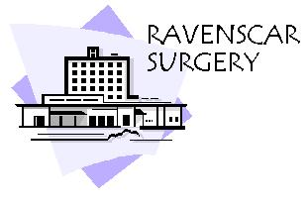
Dr K Boyd
Mrs M S Hay
Mrs J Corrie-Smith
Redcar Primary Care Hospital
Westdyke Road
Redcar
TS10 4NW
Tele: 01642 759090
Fax: 01642 759099
www.ravenscar.gpsurgery.net

RAVENSCAR SURGERY PATIENT GROUP

MINUTES
1st October 2013
12:00PM
MEETING ROOM 2 RPCH

Present: Andrea Johnson (Practice Secretary)
Julie Moore (Practice Administrator)
Ron Sabiston
Lesley Hutchinson (Chair)
Kathleen Walker
Irene Hambley
Aaron Goodwin (Virtual)

Apologies: Sue White
Jim White
Ron Wood

- Minutes of last meeting

Nothing arising minutes accepted as a true record.

- Action Plan 2013/2014 update

- This was discussed and agreed at the last meeting
- The action plan 2013/2014 is displayed on the Ravenscar Surgery website.
- Invites are being sent out bimonthly to a selection of patients across the practice demographics.
- Flu clinics are to begin this month.

- PG Rota for Flu Clinics
  - Ron & Lesley volunteered their time again – Andrea to email/telephone with the dates next week.
  - Practice would like to thank the group for their involvement.

- Food Bank Donations/Vouchers

  - Julie addressed the meeting to let all know that we had now signed up and the practice have been issued with vouchers. Dr Boyd and Nurse Practitioner are aware that they can give out to any patients who are in need.

- Chronic Disease and >60s holiday insurance
  - In Ron’s absence Andrea distributed Ron’s finished project to the group.
  - Andrea to hand the information to the travel nurse for patients information.

- Date and time of next meeting

  - To be confirmed – in the new year.

Meeting was then closed.

