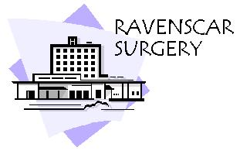
Dr K Boyd
Mrs M S Hay
Mrs J Corrie-Smith
Redcar Primary Care Hospital
Westdyke Road
Redcar
TS10 4NW
Tele: 01642 759090
Fax: 01642 759099
www.ravenscar.gpsurgery.net

RAVENSCAR SURGERY PATIENT GROUP

MINUTES
11TH February 2014
12:00PM
MEETING ROOM 4 RPCH

Present: Andrea Johnson (Practice Secretary)
Julie Moore (Practice Administrator)
Ron Sabiston
Susan White
James White
Lesley Hutchinson (Chair)
Kathleen Walker
Ron Wood
Aaron Goodwin (Virtual)

Apologies: Nil

- Minutes of last meeting

Nothing arising minutes accepted as a true record.

- CQC Visit

Lesley addressed the meeting and congratulated the practice for having done so well to comply with CQC – the practice passed with flying colours.
Practice and Group to keep up the good work. Andrea informed the group that the report can be accessed on the CQC website.

- Action Plan 2013/2014

The Action Plan that was agreed earlier in the year has been complied with and the group will devise a new one for 2014/15 this will be discussed at the next meeting April 2014.

- Practice Survey

  - Results were collated by Andrea and Julie the survey was handed out in October/November 2013.
  - The results were discussed at length by the patient group. It was felt that there would be no need for any action at the moment as the practice was well run, this reflected in the survey.
  - Patient Group representatives would be more involved in the survey next year and this will be included in the action plan.

- Food Bank

  - We are now registered and will be running a food donation in the very near future.

- Any other business

- NHS call to Action – to include in the action plan for next year and discuss at length at a meeting set up for this alone.

- Date and time of next meeting

  - To be confirmed.

Meeting was then closed.

